Data Collection and Cleaning in the Apparel and Textiles Industry

- Project Title: Data Collection and Cleaning in the Apparel and Textiles Industry
- Name: Manya Gupta
- Week: Week 1
- Domain: Data Analytics
- Submission Date: 14-07-26

Table of Contents
- Introduction
- Objective
- Data Source Identification
- Data Collection Strategy
- Dataset Description
- Data Cleaning Methodology
- Python Tools and Libraries
- Results
- Challenges
- Limitations
- Conclusion
12.References

1. Introduction
Data collection and cleaning are essential steps in every data analytics project. High-quality data improves the reliability of insights and supports better decision-making. In the apparel and textiles industry, clean and organized data helps businesses understand customer preferences, product trends, seasonal demand, and market performance. This project simulates a real-world data preparation workflow using publicly available datasets and Python.

2. Objective
The objective of this project is to identify publicly available datasets related to the apparel and textiles industry, collect relevant data, clean and preprocess the datasets using Python, and prepare an analysis-ready dataset for future business insights.

3. Data Source Identification

Dataset 1
Name: Dress Recommendation Dataset
Source: OpenML
Format: ARFF
Purpose:
- Consumer preferences
- Dress styles
- Product attributes
- Customer recommendations
Reason for Selection:
This dataset contains attributes such as style, price category, rating, season, material, decoration, and recommendation, making it suitable for understanding consumer preferences in the apparel industry.
Screenshot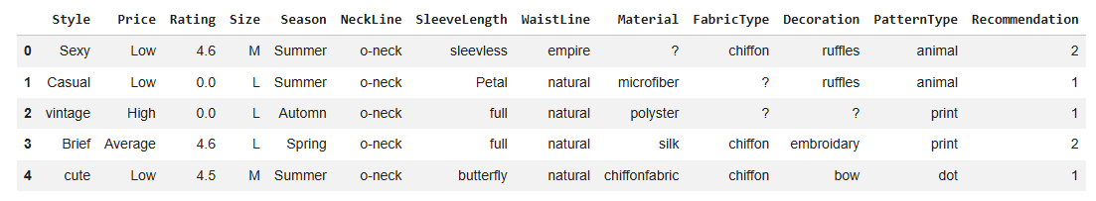Dataset 2
Name: Fashion Product Images Dataset
Source: Kaggle
Format: CSV
Purpose:
- Product information
- Brand analysis
- Product pricing
- Color trends
Reason for Selection:
The dataset contains information about fashion products, including brand, price, gender, product description, and color, which supports market and consumer trend analysis.
4. Data Collection Strategy
The following steps were followed:
- Identified publicly available datasets from OpenML and Kaggle.
- Downloaded the datasets.
- Verified dataset formats.
- Imported datasets into Python using pandas and scipy.io.arff.
- Inspected dataset structure and metadata.
- Renamed columns for readability.
- Converted byte strings into readable text.
- Identified missing values and duplicates.
- Cleaned the data.
- Saved the cleaned dataset as a CSV file.
Screenshot
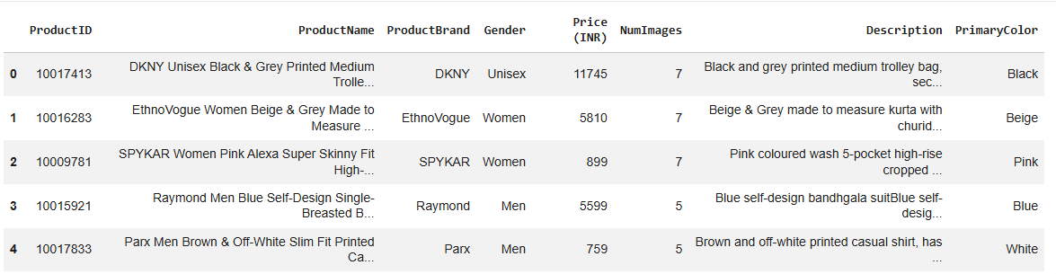

5. Dataset Description
The Dress Recommendation Dataset contains product-related attributes such as:
- Style
- Price Category
- Rating
- Size
- Season
- Neckline
- Sleeve Length
- Waist Line
- Material
- Fabric Type
- Decoration
- Pattern Type
- Recommendation
The Fashion Product Images Dataset contains:
- Product Name
- Brand
- Gender
- Price (INR)
- Color
- Product Description
6. Data Cleaning Methodology
The following techniques were applied:
- Renamed columns
- Decoded byte strings
- Replaced "?" values with missing values (NaN)
- Checked missing values using isnull()
- Filled missing categorical values using the mode
- Checked and removed duplicate records
- Standardized data formats
- Saved the cleaned dataset
7. Python Tools and Libraries
- Python
- Google Colab
- Pandas
- NumPy
- SciPy (scipy.io.arff)
- Matplotlib

8. Results
The cleaned dataset:
- Contains meaningful column names
- Has readable text values
- Has missing values handled
- Has duplicate records removed
- Is ready for visualization and analysis

9. Challenges
- Loading ARFF files
- Byte-encoded values
- Missing values represented by "?"
- Multiple categorical attributes
- Dataset standardization
10. Limitations
- Public datasets may contain incomplete records.
- Some attributes have many missing values.
- The dataset may not represent the entire apparel market.
- Consumer preferences may change over time.

11. Conclusion
This project successfully demonstrated the process of collecting and cleaning publicly available apparel datasets. Python and its libraries were used to preprocess the data by renaming columns, decoding byte strings, handling missing values, and removing duplicates. The cleaned dataset is now suitable for further analysis, visualization, and business decision-making.
12. References
- OpenML – Dress Recommendation Dataset
- Kaggle – Fashion Product Images Dataset
- Pandas Documentation
- NumPy Documentation
- SciPy Documentation

